XV. GIMNAZIJA
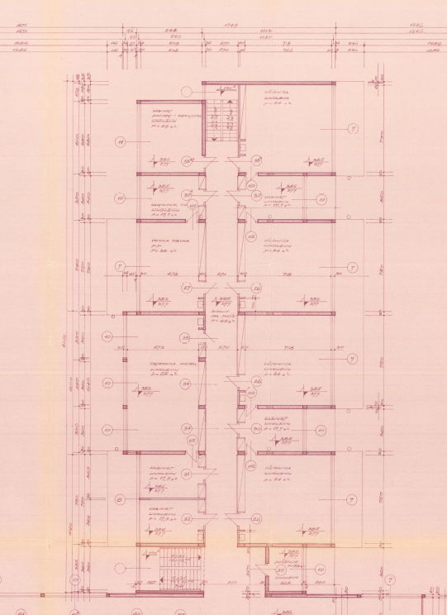

PHOTO
(insert SCAN)
IB World School
Jordanovac 8, Zagreb 10000
Croatia

APPLICATION FORM
INTERNATIONAL BACCALAUREATE MIDDLE YEARS PROGRAMME
SCHOOL YEAR 2020/2021
PART I - COMPLETED BY CANDIDATE OR PARENT/GUARDIAN
Applying to grade: | 1. | Enrolment date:
Application date: | 10.7.2020. | Enrolment date:

STUDENT
Name (family name first): | Šimić
Gender (M/F):
Date of Birth:
Place of Birth:
Nationality:
Citizenship:
Address in Croatia:
Telephone No. (home and mobile)
Permanent Address (if different):
E-mail address:
OIB for foreign citizens:
FAMILY
Mother’s Name:
OIB:
Citizenship:
Occupation:
Name of Employer:
Business Phone No. & mobile:
E-mail address:
Father’s Name:
OIB:
Citizenship:
Occupation:
Name of Employer:
Business Phone No. and mobile:
E-mail address:
Are the parents living apart,
separated or divorced?
Student lives with:
Number of children in the family:

PREVIOUS SCHOOLS ATTENDED:
Name of School | City / Country | From/To (Month &Year) | Grade
LANGUAGE PROFILE:
Student’s mother tongue / best language:
Other languages spoken:
English studied for how many years:

HAS THE STUDENT EVER BEEN HELD BACK OR MOVED UP A GRADE? (If yes, please provide details):
DOES THE STUDENT HAVE ANY MEDICAL CONDITION? (If yes, please provide
details):
ENGAGEMENT IN SPORTS ACTIVITIES (name activities):
ENGAGEMENT IN MUSIC OR ANY ART ACTIVITY:
ENGAGEMENT IN ANY OTHER EXTRACURRICULAR ACTIVITY, HUMANITARIAN OR COMMUNITY ORGANISATION (e.g. Red Cross):
PARTICIPATION IN ANY KNOWLEDGE COMPETITION (name the competition and the place held):
Documents to be enclosed with this application form:
1. grade transcripts of two previous years (Official school transcripts)
2. proof of student’s citizenship (and parent’s if different)
3. two photos (passport size) or scanned photo on the top of the Application form
PART II - COMPLETED BY CANDIDATE (IN BLOCK CAPITALS)
DESCRIBE IN ENGLISH REASONS FOR APPLYING TO THE IBMYP
Date: |  | Signature:

PART III - COMPLETED BY PARENTS OR GUARDIANS
1. I hereby agree that my child be enrolled in the IBMYP (YES/NO):
2. Why do you think this programme is good for your child?
3. I hereby declare that I have been introduced to the IBMYP and that my child will comply with the school regulations and adhere to the IBMYP Curriculum.

Date: |  | Signature:

PART IV – NOTICE OF PROCESSING PERSONAL DATA WHEN CONSENT OF DATA SUBJECT IS NOT NECESSARY – SIGNED BY PARENT/GUARDIAN

XV. gimnazija processes student's and parent's personal data because of fulfilling obligations in the field of education according to the Croatian law, IB regulations and internal school acts.

CONTROLLER | XV. gimnazija
DATA PROTECTION OFFICER'S CONTACT | tajnistvo@mioc.hr
DATA SUBJECT | - student  - parent/guardian
LEGAL BASIS | - Primary and Secondary School Education Act  - by-laws  - Statut XV. gimnazije  - IBMYP: General regulations  - IBDP: General regulations
PURPOSES | - protection the vital interests of the data subject  - compliance with a legal obligation to which the controller is subject  - performance of a task carried out in the public interest or in the exercise of official authority vested in the controller  - performance of a contract to which the data subject is party or in order to take steps at the request of the data subject prior to entering into a contract  - protection of persons and property
CATEGORIES OF RECIPIENTS | - government bodies in charge  - public institutions in charge  - founder (City of Zagreb) and founder's bodies in charge  - service providers in extra-curricular activities  - International Baccalaureate Organization  - institutions where students volunteer for CAS requirements  - bodies in charge of enforcement proceedings
STORING PERIOD | - permanent except:  - data concerning health and family status – 5 years  - personal data obtained by a video surveillance of common rooms – maximum 6 months, except when longer storing is necessary
DATA SUBJECT'S RIGHTS | - to request access to his/her personal data  - to request rectification or erasure of personal data or restriction of processing concerning the data subject  - to object to the controller  - to object to Croatian Personal Data Protection Agency  - data portability
OBLIGATION OF PROVIDING PERSONAL DATA | - statutory or contractual requirement/a requirement necessary to enter into a contract
Signature:

PART V - COMPLETED BY SCHOOL THE CANDIDATE HAS ATTENDED LAST
Student:
- We kindly ask the homeroom teacher to provide her/his opinion about the candidate which should include:
  - estimation of candidate’s abilities and working habits
  - personal characteristics
  - extracurricular activities
  - attendance
2. Estimate the following characteristics of the candidate:
 | A  Excellent | B  Above  average | C  Average | D  Below average | E  No basis for judgement

Ability to work in a group
Adaptability
Communicative skills
Care for others
Creativity
Diligence
Initiative
Maturity
Motivation
Open-mindedness
Self-control
Self-confidence

Homeroom Teacher’s Name:
Date: |  | Signature:

