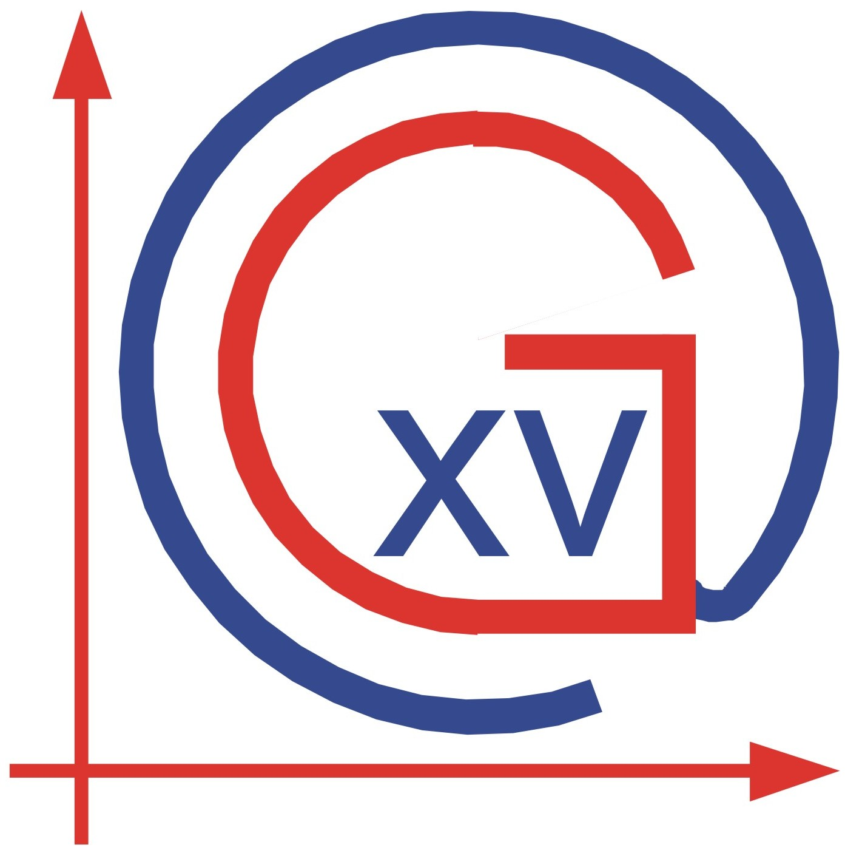
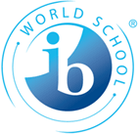

XV. GIMNAZIJA

INTERNATIONAL BACCALAUREATE
DIPLOMA PROGRAM

Zagreb, Jordanovac 8

STUDENT HANDBOOK
ON
SCHOOL RULES

SCHOOL YEAR 2014/2015

ZAGREB, September 2014

Dear students,

It is with great pleasure that we welcome you to our school - IB Diploma Programme!

XV. Gimnazija is a state school that has been offering an international programme since school year 1991/92. For delivery of both International Baccalaureate Middle Years (Grades 9 & 19) and Diploma Program (Grades 11 & 12) our school is authorised by the International Baccalaureate Organization and the Ministry of Education and Sports of the Republic of Croatia. Teachers and administrators have been working diligently and enthusiastically to build a quality balanced programme. New improvements and adjustments are still being made regarding school facilities and equipment.

The Diploma Program puts high demands on both students and teachers. Students will be challenged to develop their knowledge, skills and positive attitudes. However, we are convinced that hard work and responsibility will yield the highest standards of performance.

We wish you a successful and rewarding experience in the IB Diploma Programme in XV. Gimnazija.

Your teachers!

2014/2015 SUBJECTS AND TEACHERS

SUBJECT | NAME | TEACHER’S EMAIL ADDRESS
Principal | Josip Harcet M.Sc. | jharcet@mioc.hr
IBDIP Coordinator &  CAS Coordinator | Ljiljana Crnković, M.A. | ibzagreb-dip@hi.t-com.hr
Croatian A Literature | Božica Jelaković, M.A. | bozica_jelakovic@yahoo.com
Croatian A Literature | Marija Bilić, M.A. | marija.bilic8@zg.t-com.hr
Croatian A Literature | Senka Škrnjug, M.A. | senka.skrnjug@hi.htnet.hr
English A Literature  English B | Iva Čorak, M.A. | iva_corak@yahoo.com
English A Literature  English B | Zorana Franić, M.A. | franic.zorana@gmail.com
English A Literature  English B | Lada Silađin, M.A. | ladadaw@yahoo.co.uk
Economics | Krunoslav Horvat, M.A. | krunoslav.horvat@inet.hr
Psychology | Andrea Šlaus-Kokotović, M.A. | slauskokotovic@yahoo.com
Biology HL | Biljana Agotić Smital, M.Sc. | bsmital@inet.hr
Biology SL | Emil Gaal, M.Sc. | egaal@mioc.hr
Biology SL | Mihaela Marceljak Ilić, M.Sc. | mihaela.marceljak@zg.t-com.hr
Chemistry | Zrinka Topličan, M.Sc. | ztoplican@yahoo.com
Physics | Ines Dukić, M.Sc. | idukic@mioc.hr
Mathematics | Marina Bilić, M.Sc. | m.bilic@hi.htnet.hr
Mathematics | Jelena Gusić, M.Sc. | jgusic@gmail.com
German B | Sandra Markota Sever, M.A. | sandra.markota@zg.htnet.hr
French B | Loreana Selišek-Butina, M.A. | ibzagreb-cas@hi.t-com.hr
Visual Arts | Kristina Rismondo, M.A. | kristina.rismondo@gmail.com  kristinar@net.hr
Theory of Knowledge | Vladimir Rismondo, Ph.D. | vladimir.rismondo@zg.t-com.hr

ATTENDANCE PROCEDURES

IB students will use the main school entrance or entrance from Čikoševa street that is open only in the morning.

Attendance
Attendance roll will be taken at the beginning of each class period and notified in the class book.
For the award of report cards and diploma, full attendance is required. Unavoidable absences must be confirmed by a note from parents and a doctor. Phone calls will not be sufficient, personal visit to the homeroom teacher is required.
For absence, other than illness, a written request is required submitted ahead of time, signed by both student and parents:
- a single day absence is granted by the homeroom teacher;
- two day absence by the IBDIP Coordinator;
- three day by the principal;
- for the absence longer than three days request must be submitted to the teaching staff – Nastavničko vijeće.

Tardiness
Always be punctual!
Students are required to be in the assigned classroom immediately after the school bell rings prepared for their class. Should a student arrive late he/she will not be admitted into the classroom and will have to state the reason of his/her absence to the class teacher and homeroom teacher and provide a letter from a parent. In this situation, the student should use the school library or the cafeteria.

Excused Absences
Students are expected to be in attendance each school day.
Those who are absent or late to school can be excused by a written excuse from parents submitted personally to the homeroom teacher. The excuse should be presented within five days and must include
1. the date or dates of absence.
2. the reason for the absence.
3. the parent’s or guardian’s signature.
4. doctor’s report.
In case of extensive absence (20 % or more of assigned teaching time/lessons per subject) teacher will decide not to grade the student at the end of the term, but to request the student to take the exam in that subject.

Unexcused Absences
If a student does not bring written permission from home excusing him/her for an absence, he/she will receive an UNEXCUSED absence from class, which will result in a disciplinary action.
1. Up to 5 unexcused periods will result in a formal warning;
2. 6 to 10 unexcused periods will result in a written reprimand, and the
grade “mediocre behavior”;
3. 11 to 14 will result in a final warning before expulsion, and the grade
“poor behavior”;
4. 15 absences will result in the process of intensive monitoring;
5. More then 15 unexcused periods will result in expulsion from school.

PUNCTUALITY

- School begins at 8:00.
- Students must arrive punctually to the assigned classroom with their books and all necessary materials. They must regularly attend all classes.
- Lunch break of 25 min is at 10,25. Students provide for their own lunch.
- Punctuality after breaks is as important as in the morning.
- Backyard door is open only during the lunch and 10 min break

ILLNESS AT SCHOOL

Students who become ill at school should report to the homeroom, class teacher or IB Coordinator. Students must not leave school without permission.

CATCHING UP ON WORK MISSED

After an absence, it is the student’s responsibility to find out which assignments have been missed. It is also the student’s responsibility to set up a schedule to catch up on work missed during an extended absence. In addition teachers welcome students with specific questions to visit them during their office hours.

RULES ON USE OF THE SCHOOL FACILITIES

1. Students must follow their school schedule. After classes, students are allowed to:
a. use the library from 8:00 to 16:00.
b. use the computer lab according to the schedule posted on the door.
c. use the gym for the scheduled extra-curricular activities.

2. If a gap appears in a student’s schedule, he/she should use the school facilities. No student should roam the halls during class periods.

3. During breaks, when changing rooms, students are requested to use the right side of the corridor and stairs to avoid crowding. The shift should be made efficiently and orderly.

CHANGES IN SUBJECT AND LEVEL

During September of the 11th Grade students have the opportunity to change once their subjects and levels. A written request should be submitted signed by both parents and the student, and an interview is required with the IB Coordinator. Possibility of changing subjects ends on October 1.

STUDENT TRANSFERS

If you must change schools for any reason during the school year, parents should contact the I.B. Coordinator. Students are required to return all books to the library and to subject teachers, receive their signature, and submit the form to IB Coordinator prior to their departure. Locker should be empted, and all the school fees should be covered as well. It is only then that you can receive a report card with your grades.

STUDENT DISCIPLINE

Discipline rules at the school have been designed to allow students as much freedom and responsibility as possible under the circumstances and to ensure that the school’s primary function- education- is achieved.

The school reserves the right to take disciplinary action if a student’s behaviour in or out of school affects the reputation or well-being of the school community.

DISCIPLINARY PROCEDURES

The individual classroom teacher is expected to deal with tardiness and routine student behaviour. Other problems such as habitual class cutting, repeated lateness, and repeated class disruption will be dealt with by the homeroom teacher and IBDIP Coordinator. The teaching staff will impose appropriate penalties.

The homeroom teacher or the IBDIP Coordinator will contact the student’s parents / guardians and appropriate authorities immediately when the misbehaviour is related to assault, vandalism, theft, drugs, alcohol or destruction of personal or public property or after a three day long absence without a proper notification.

CODE OF CONDUCT

Students are expected to conduct themselves in a manner that brings respect and honour to themselves, their parents and the school.

Courtesy in behaviour, language and manner is expected of students at all times. Matters of discourtesy in the classroom will be handled by the classroom teacher. Discourtesy outside the classroom will be referred to the homeroom teacher and IBDIP Coordinator.

Students are expected to:
- always demonstrate respect for all fellow students and school personnel
- be respectful of school property
- not sit on window sills
- not write on desks or walls
- not move school furniture without permission
- not put their backpacks on the desk during classes
- pick up litter at all times, whether they drop it or not
- never touch a fire extinguisher in fun; their purpose is to prevent small fire to spread
- not take anything that belongs to somebody else
- not smoke – smoking is not allowed in the school building
- not put headphones during classes
- not eat or drink during classes; no food may be brought into the classroom; tins, napkins, and leftovers must be disposed of in proper garbage containers
- turn off their cellular phones during the lessons

NOTE: Electronic devices, knives, alcohol, drugs and tobacco are strictly forbidden in the school. Headphones or cellular phones will be repossessed by the teacher in case of their use in the classroom and returned to parents only. In case of repeated violation headphones or cellular phones will be kept in school until the end of the school year.

IN CASE OF MISCONDUCT

For misbehaviour or rude conduct, the school has a system of penalties:
- A warning will be given for minor disciplinary violations
- A written reprimand will be given to the student and sent to the parent for disrupting the class, assaulting another student, faculty, or school personnel
- Any major violation will result in a final warning before expulsion
- Persistent violation will result in expulsion from school

In addition, the following misbehaviour may result in expulsion from school:
- 15 or more unexcused periods
- intentional damage of the school or another person’s property
- forgery, theft, vandalism, drug and alcohol consumption

STUDENT’S DRESS CODE

It is expected that students are appropriately dressed. Students and parents must take the responsibility to ensure that he/she has a neat appearance.
Using the gym, students should bring an extra pair of tennis shoes and the required outfit.
Students should use their lockers to keep all personal property (coats, umbrellas, etc.) secured.
During the use of the Gym students are to entrust their valuable possessions (watches, cellular phones, money, etc.) to the teacher.
The school does not take any responsibility for lost, misplaced or stolen valuables but will assist our students in taking appropriate steps.

TEXTBOOKS

Students are responsible for the textbooks issued. All books are school property and must be cared for and returned in the condition received. If books are lost or damaged, student will be billed. Handing in a book is not enough; it must be the one you were assigned. At the end of the year, before receiving the report card, the student should submit the “Return of books form” as a proof that all books have been returned.

LOCKERS

Please do not force the lock or your locker. Do not keep valuables inside. You are not allowed to attach stickers or write on your locker. Keep your lockers clean and tidy. Do not leave books, bags, and clothes on top of lockers.

VISITORS TO THE SCHOOL

You may only bring visitors into the school with the permission of the Head of School. This is normally granted for one day. The beginning or the end of the school year is not a good time for visitors to come to the school. You are fully responsible for your visitor while he or she is in the school. Do not take visitors into a classroom without first asking the teacher concerned.

STUDENT APPRECIATION

During and at the end of the school year, awards will be given to students for
A) excellent and outstanding academic performance.
B) creative participation in curricular and extra-curricular activities.
C) participation in outside of school competitions.
D) exercising polite, well-mannered behaviour which serves as a role model to other students.

Awards may be given by the teaching staff based on the recommendation of the homeroom teacher, class teacher, or other faculty members.

PROMOTION TO THE NEXT YEAR/GRADE

Requirements for the promotion to Grade 12:
- a minimum of 23 points in your six Diploma courses. Extra certificate subjects do not contribute to the total number of points.
- not a single negative grade in any of your Diploma courses (1 in SL or 1 or 2 in HL courses).

Students with one or two negative grades or with less than 23 points will have to take re-sit exams at the end of the school year. Students who fail to submit the required lab reports, projects, essays, portfolios, and CAS diaries will have to re-sit the subject as well. First re-sit session takes place at the beginning of July and the second at the end of August. Students with a negative grade or with less than 23 points after taking re-sit exams; will have to do Grade 11 or 12 again.

IB grading scale

IB grading scale of 1 – 7 is applied in all Diploma courses and the equivalence to scale 1-5 is as follows:

IB grade | 1-5 equivalence | Total points | Overall achievement / Uspjeh
7 | 5 | 34 + | Excellent / Odličan
6 | 5 | 28 - 33 | Very good/ Vrlo dobar
5 | 4 | 24 - 27 | Good / Dobar
4 | 3 | 23 | Sufficient / Dovoljan
3 | 2 | 22 | Failed / Nedovoljan
2 | 2 (at SL), 1 at HL | GPA – grade point average is calculated in e-matica inclusive of extra certificate and school complimentary course.
1 | 1

Academic Honesty

IBO is very particular about academic honesty, malpractice, plagiarism or cheating.

The candidate is ultimately responsible for ensuring that all work submitted for assessment is authentic;
- work or ideas of others must be fully and correctly acknowledged;
- candidates must compy with all internal school deadlines;
- candidates are expected to review their own work before submission for assessment to identify any passages, data, graphs, photographs, computer programs etc. that still require acknowledgement;
- class material should be acknowledged as well;
- teachers, while reading candidate's work, must be vigilant for obvious changes in a candidate's style of writing;
- IB examiners use Internet sites to detect plagiarized text.

If accused of malpractice:
- students must provide their full report;
- teacher must provide a report;
- Coordinator must provide a report

Possible penalty by IBO is:
- no grade awarded for the subject, no Diploma
- no points for Internal Assessment

FINAL IB EXAMS (GRADUATION) AND AWARD OF THE IB DIPLOMA

Conditions for award of the IB diploma:

1. All assessment components for each of the six subjects and the additional IB diploma requirements must be completed for the award of the IB diploma.

2. A candidate will not qualify for the award of the diploma if certain requirements have not been met. (Refer to the General regulations: Diploma Programme .)
- Candidate’s total points are less than 24.
- An N has been given for one or more subjects, theory of knowledge or the extended essay.
- A grade E has been awarded for both theory of knowledge and the extended essay.
- There is a grade 1 awarded in any subject and level.
- CAS requirements have not been completed.
- Candidate is guilty of malpractice.
- Grade 3 or below has been awarded four or more times.
3. Candidates with 24 to 27 points inclusive will not qualify for the award of
the diploma if:
- There is one or more grade 2 awarded at higher level.
- Grade 2 at standard level awarded two or more times.
- Candidate has registered for three higher level subjects, and gained fewer than 12 points on these.
- Candidate has registered for three standard level subjects, and gained fewer than 9 points on these.
- Candidate has registered for four higher level subjects, and gained fewer than 16 points on these.
- Candidate has registered for two standard level subjects, and gained fewer than 6 points on these.
- Candidate has a grade E in either the extended essay or theory of knowledge.
4. Candidates with 28 points or more will not qualify for the award of the diploma if:
- Grade 2 at higher level awarded two or more times.
- Grade 2 at standard level has been awarded three times.
- Candidate has registered for three higher level subjects, and gained fewer than 11 points on these.
- Candidate has registered for three standard level subjects, and gained fewer than 8 points on these.
- Candidate has registered for four higher level subjects, and gained fewer than 14 points on these.
- Candidate has registered for two standard level subjects, and gained fewer than 5 points on these.

5. A maximum of three examination sessions is allowed in which to satisfy the requirements for the award of the IB diploma.

Please acknowledge that even without a negative grade or with 24 points achieved, you may still not receive the IB Diploma due to specific failing conditions.

IB DIPLOMA RECOGNITION

IB Diploma is widely recognized at universities in every country. National requirements regarding the IB Diploma recognition should be checked out with the national Ministry of education and specific universities ( Germany requires that all students should take Math or Science at HL ).

In Croatia IB Diploma is equivalent to Državna matura:

„Kandidati koji su hrvatski državljani i srednje obrazovanje završavaju ili su završili u međunarodnome programu International Baccalaureate (IB) od 2010. godine do danas u Republici Hrvatskoj, mogu se prijaviti na visoka učilišta u Republici Hrvatskoj, pri čemu će se rezultati njihovih završnih ispita priznati kao usporedivi rezultati ispita državne mature, no moraju polagati ispite državne mature koje studijski program zahtijeva, a koje nisu polagali unutar IB mature.“ Iz Brošure: Prijave ispita državne mature i prijave za upis na studijske programe na www.postani student.

Konverzijska tablica IB ocjena u ocjene od 1 do 5 na državnoj maturi za bodove na Postani student – gledati svaki predmet posebno

IB SL | DM A | IB HL  IB HL 6 i 7 - 7 dobiva sredinu gornje polovice bodova ocjene 5 na  državnoj maturi, a 6 sredinu donje polovice 5 dm,  IB HL 5 - dobiva sredinu gornje polovice bodova ocjene 4 dm,  IB HL 4 - dobiva donju granicu bodova ocjene 4 dm,  IB HL 3 - dobiva sredinu bodova ocjene 3 dm,  IB HL 2 - dobiva sredinu bodova ocjene 2 dm samo ako je  dobivena IB diploma.  IB SL 7 - dobiva sredinu bodova ocjene 5 dm,  IB SL 6 - dobiva donju granicu bodova ocjene 5 dm,  IB SL 5 - dobiva sredinu bodova ocjene 4 dm,  IB SL 4 - dobiva sredinu gornje polovice bodova ocjene 3 dm,  IB SL 3- dobiva sredinu donje polovice bodova ocjene 3 dm,  IB SL 2 - dobiva sredinu bodova ocjene 2 dm.
 | 5 | 7
7  6 | 5 | 6
5 | 4 | 5
5 | 4 | 4
4 | 3
3 | 3 | 3
2 | 2 | 2

Avarage grade of all grades (extra certificate and school somplementary grades included) are calculated on Postani student for the college enrollment purposes.

