FRENCH (Phases 1-6) COURSE DESCRIPTION

WHAT IS THE COURSE ABOUT?

Learning French – language acquisition in the MYP programme helps students to discover, understand and accept multicultural diversity of French speaking world and encourage them to use this language effectively as a means of practical communication. Students develop tolerance, respect, differences through intercultural understanding and learning about France. Discussing and comparing languages, habits, relationships and everyday life in different countries. The French culture compared to the respective cultures of the students.

A Student working at Phases (1-6) would show evidence of a greater cultural awareness as a result of exposure to, and appreciation of, more sophisticated forms of communication such as the media and literature. Individual and group project work relate to the themes, leading to recorded, oral presentations, and further extended debates and discussions. The courses are flexible in that it allows for the integration of Interdisciplinary units where appropriate.

Selectively, we encourage greater complexity in expression through the use of tenses such as the present (le présent), the perfect (le passé composé), imperfect (l'imparfait), past historic (le passé simple, le passé récent), pluperfect (le plus–que-parfait), future (le futur simple, le futur proche), conditional (le conditionnel) and the use of subjunctive mood (le subjonctif).

Materials are chosen from appropriate text–book and from a number of authentic sources such as reference material from library, songs, shorts stories, magazines and cartoons, audio-visual materials designed for French native speakers, classic literature, radio, television, films and Internet.

At the end of the each Unit the students will have to fill in the self-reflection and self-evaluation sheet and sometimes the Language Portfolio-self assessment sheet.
MYP 4: The school offers three lessons of French per week (Phases 1 and 2)
MYP 5: The school offers three lessons of French per week (Phases 3 and 4)

TOPICS :
MYP 4
UNIT 1 : FAISONS CONNAISSANCE - Moi et les autres

UNIT 2 : MANIÈRE DE VIVRE

UNIT 3 : GASTRONOMIE EN France

UNIT 4 : LOISIRS

MYP 5
UNIT 1 : CADRE DE VIE
UNIT 2 : MODE
UNIT 3 : VOUS AVEZ DIT FRANCE ?

UNIT 4 : MÉDIAMANIA

The MYP:

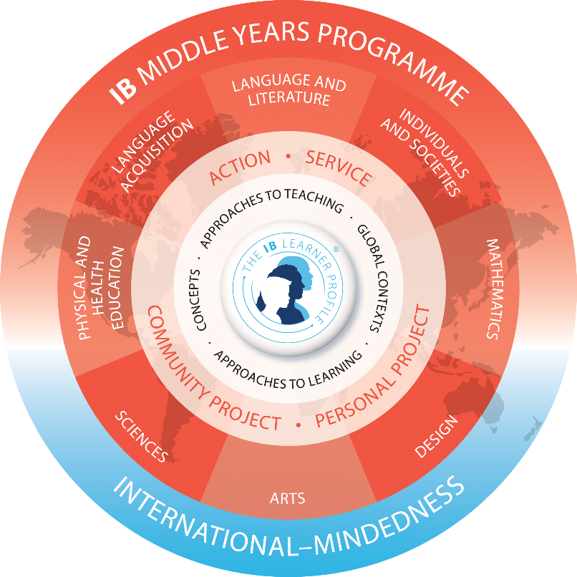

- addresses holistically students’ intellectual, social, emotional and physical well-being
- provides students with opportunities to develop the knowledge, attitudes and skills they need in order to manage complexity and take responsible action for the future
- ensures breadth and depth of understanding through study in eight subject groups
- requires the study of at least two languages to support students in understanding their own cultures and those of others
- empowers students to participate in service with the community
- helps to prepare students for further education, the workplace and a lifetime of learning.

Language acquisition offers many opportunities for interdisciplinary teaching and learning. Possible interdisciplinary units in this subject group could include inquiries into:

- visual and performing art forms from the culture of the language being studied (arts)
- interactive multimedia products that can be used to communicate linguistic concepts (design)
- sports and games from the culture of the language being studied (physical and health education)
- the interpretation of concepts such as time, place and space in the cultural context of the language being studied (individuals and societies).

Aims:

The aims of the teaching and study of modern foreign French language are to:
• gain proficiency in an additional language while supporting maintenance of their mother tongue and cultural heritage
• develop a respect for, and understanding of, diverse linguistic and cultural heritages
• develop the student’s communication skills necessary for further language learning, and for study, work and leisure in a range of authentic contexts and for a variety of audiences and purposes
• enable the student to develop multiliteracy skills through the use of a range of learning tools, such as multimedia, in the various modes of communication
• enable the student to develop an appreciation of a variety of literary and non-literary texts and to develop critical and creative techniques for comprehension and construction of meaning
• enable the student to recognize and use language as a vehicle of thought, reflection, self-expression and learning in other subjects, and as a tool for enhancing literacy
• enable the student to understand the nature of language and the process of language learning, which comprises the integration of linguistic, cultural and social components
• offer insight into the cultural characteristics of the communities where the language is spoken
• encourage an awareness and understanding of the perspectives of people from own and other cultures, leading to involvement and action in own and other communities
• foster curiosity, inquiry and a lifelong interest in, and enjoyment of, language learning.

Objectives:
The language acquisition subject group objectives represent some of the essential processes of language and have been organized under the same four communicative processes for each of the six phases in order to assist teachers with planning, teaching and assessing.
They are as follows.
A Comprehending spoken and visual text
B Comprehending written and visual text
C Communicating in response to spoken, written and visual text
D Using language in spoken and written form

Teaching and learning in French B is organized into six phases.

Phase 1 | Phase 2 | Phase 3 | Phase 4 | Phase 5 | Phase 6
A very limited  range of  interpersonal  and cultural  contexts | A limited  range of  interpersonal  and cultural  contexts | A limited  range of  interpersonal  and cultural  contexts | A range of  interpersonal  and cultural  contexts | A range of  interpersonal  and cultural  contexts | A wide range of  interpersonal  and cultural  contexts
Use basic  vocabulary | Use basic  language | Use language  accurately | Use language  accurately | Use language  accurately and  effectively | Use oratory  technique
Simple short  texts | Simple texts | A limited range  of texts | A range of texts | A range of texts | A wide range of  texts
Interact in  simple and  rehearsed  exchanges | Interact in  basic rehearsed  and some  unrehearsed  exchanges | Interact in  rehearsed and  unrehearsed  exchanges | Engage actively | Engage actively | Engage actively
Understand  and respond | Understand  and respond | Understand  and respond | Understand,  interpret and  respond | Understand,  analyse and  respond | Understand,  analyse,  evaluate and  respond
Identify and  recognize | Recognize and  understand | Understand | Construct  meaning/  interpret | Construct  meaning/  analyse | Evaluate

ASSESSMENT STRATEGIES:

Language acquisition: English, French, German and Croatian
Assessment components:
Assessment for phases 1 to 6 of MYP language acquisition is criterion-related, based on four equally weighted assessment criteria.

Criterion A | Comprehending spoken and visual text | Maximum 8 points
Criterion B | Comprehending written and visual text | Maximum 8 points
Criterion C | Communicating in response to spoken, written and visual text | Maximum 8 points
Criterion D | Using language in spoken and written form | Maximum 8 points

The language acquisition subject group objectives correspond to assessment criteria. Each criterion has nine possible achievement levels (0–8), divided into four bands that generally represent limited (1–2); adequate (3–4); substantial (5–6); and excellent (7–8) performance. Each band has its own unique descriptor that teachers use to make “best-fit” judgments about students’ progress and achievement.

Each objective is elaborated by a number of strands; a strand is an aspect or indicator of the learning expectation.
All strands of all four assessment criteria are addressed at least twice in each year of the MYP Language acquisition.

Comprehending spoken and visual text and Comprehending written and visual text encompass aspects of listening or reading and viewing, and involve the student in interpreting and constructing meaning from spoken or written and visual text to understand how images presented with oral or written text interplay to convey ideas, values and attitudes.

Communicating in response to spoken, written and visual text is a category that gives students opportunities to develop their communication skills by interacting on a range of topics of personal, local and global interest and significance, and responding to spoken, written and visual text in the target language.

Using language in spoken and written form is a category which relates to the correct and appropriate use of the spoken and written target language.

Throughout a Language acquisition course, teachers use formative assessments to determine students’ strengths and limitations in accessing the required content knowledge and skills, provide needed support in making progress and to allow for students to actively engage in and reflect on their educational experience in each class. While preparing students for the summative assessments, language teachers use a variety of formative assessments to scaffolding student development of content knowledge and skills.

At the end of each unit in grades 9 and 10, students spike or write summative assessment task/tasks.

Points are awarded in each criterion at the end of the school year, taking into account achievements in each individual task (formative and summative assessment).

Final grades are derived according to the grade boundaries provided by the IB:

Grade | Language acquisition- all phases
 | Boundaries
1 | 0-5
2 | 6-9
3 | 10-14
4 | 15-18
5 | 19-23
6 | 24-27
7 | 28-32

French teacher: Loreana Selišek Butina, M.A.

