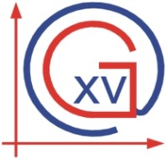 | XV. GIMNAZIJA  International Baccalaureate Department  Middle Years Programme | 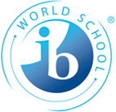
SCHOOL CALENDAR 2017/2018

SEPTEMBER 4TH , 2017 - DECEMBER 22ND, 2017 FIRST TERM

September 25th, 2017 First parents’ meeting

End of September/
Beginning of October One-day school trip (to be decided)

October 2017 Assessment workshop for parents

November 1st, no school All Saints’ Day

November 9th, 2017 Parents-teacher conference

December 15th, 2017 Christmas party

Winter holidays December 27th, 2017 – January 12th, 2018

JANUARY 15TH, 2018 - JUNE 15TH , 2018 SECOND TERM

January 15th, 2018 Beginning of 2nd term

March 1st, 2018 Personal Project deadline (MYP5 students)

March 14th, 2018 School day + Personal Project festival

March 29th-April 6th, 2018 Spring holidays

April 3rd – April 7th, 2018 London school trip (MYP5 students)

April 30th, 2018 No school
May 1st 2018 Labour day

April 2018 Parent-teacher conference (to be announced)

May 10th – May 11th, 2018 Two-day school trip

May 21st- May 25th, 2018 Exam week
May 31st 2018 Corpus Christi
June 1st, 2018 No school
June 15th, 2018 End of school

Any changes in the above school calendar will be duly noted.

MYP4 students sit Math, Croatian A, Geography and Chemistry exams, MYP5 sit Math, English A and B, Physics and Visual Arts exams

