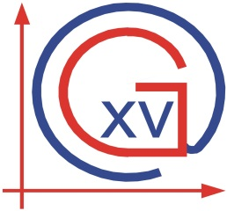
SCHOOL CALENDAR FOR IB MYP STUDENTS 2016/2017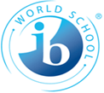

FIRST TERM

September 5th , 2016 - December 23rd 2016

September 21st, 2016 First parents’ meeting

October 14th ,2016 One-day school trip

November 1st, no school All Saints’ Day

November 10th 2016 Parents-teacher conference

December 16th, 2016 Christmas party

Winter holidays December 27th, 2016 – January 11th, 2017

SECOND TERM

January 12th, 2017 - June 14th , 2017

January 12th, 2017 (Thursday) Beginning of 2nd term

March 1st, 2017 Personal Project deadline (MYP5 students)

March 14th, 2017 School day + Personal Project festival

April 13th - April 21st, 2017 Spring holidays

April 24th-April 26th,2017 IB Evaluation visit

May 1st 2017 Labour day

May 2017 Parent-teacher conference ( to be announced)

May 19th and 20th,2017 Two-day school trip

June 14th , 2017 End of school

June 20th -25th 2017 London school trip

Any changes in the above school calendar will be duly noted.

